ProLUG 101
Unit 5 Worksheet

Instructions
Fill out this sheet as you progress through the lab and discussions. Hold onto all of your work to send to me at the end of the course.

Discussion Questions:
Unit 5 Discussion Post 1: Review the page: https://attack.mitre.org/
1. What terms and concepts are new to you?
2. Why, as a system administrator and not directly in security, do you think it’s so important to understand how your systems can be attacked? Isn’t it someone else’s problem to think about that?
3. What impact to the organization is data exfiltration? Even if you’re not a data owner or data custodian, why is it so important to understand the data on your systems?

Unit 5 Discussion Post 2: Find a blog or article on the web that discusses the user environment in Linux. You may want to search for .bashrc or (dot) environment files in Linux.
1. What types of customizations might you setup for your environment? Why?
2. What problems can you anticipate around helping users with their dot files?

Definitions/Terminology
Footprinting
Scanning
Enumeration
System Hacking
Escalation of Privilege
- Rule of least privilege
Covering Tracks
Planting Backdoors

Notes During Lecture/Class:
Links:

Terms:

Useful tools:

Lab and Assignment
Unit 5 Manage Users and Groups - To be completed outside of lecture time
Map the Internal ProLUG Network (192.168.200.0/24):
1. Map the network from one of the rocky nodes.
Using a template that you build or find from the internet, provide a 1 page summary of what you find in the network.
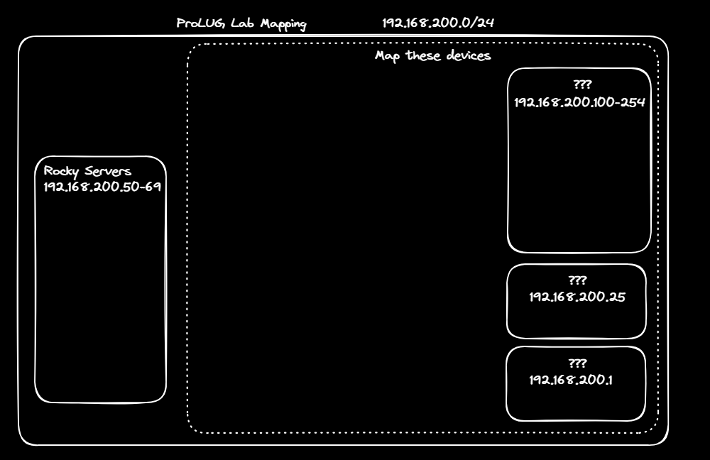
Begin working on your project from the Project Guide
Topics:
    - System Stability
    - System Performance
    - System Security
    - System monitoring
    - Kubernetes
    - Programming/Automation

You will research, design, deploy, and document a system that improves your administration of Linux systems in some way.

Digging Deeper
- Read

Reflection Questions
- What questions do you still have about this week?

